GSP270
Joseph Gautreau
Nathaniel Matteson
Andrew Megowan
Field Trip!
Abstract
The goal of this project was to see, at varying distances, the proximity of CSU and UC schools in California to federal and state public lands. This project utilized state park and federal land data, as well as generated original data by digitizing points for each CSU and UC school. Findings and data were processed through ArcMap by creating buffers zones around the school to see how much public land is within travel distance. We found that there is public land within 30 miles of every CSU and UC school in California.

Introduction
Recreation area visitors generate higher annual benefits for themselves through trip frequency when they reside in close proximity to recreation areas. (Wieler, 2006) College students are a unique demographic in their age, and their spatial distribution. Many students, even with the advent of internet access college courses, reside on or immediately around the university they attend. As such, we see mass concentrations of people aged 17-22, of whom most have their own means of transportation, or a deal of time free for educational activities. Some students are able to realize the recreational activities in their area and utilize them, and many schools have followed suit, and have integrated local resources into their courses. “Of the two supply variables (distance and cost), distance to the nearest state-protected and recreation area (SPRA) proved to be statistically significant such that a long distance to the nearest SPRA decreased the probability of participating in recreation in that area.” (Huhtala, 2009) This project aimed to find the amount of public lands that are reasonably accessible from California State University and University of California campuses, which in turn can be used to determine how such proximity can be utilized by college students and university programs alike. This project used the buffer zones of 2 miles, 10 miles, and 30 miles to represent a reasonable walking distance, a reasonably short drive, and a reasonable day trip, respectively, to the different recreational areas. Below, Figure 1, is the locator map for the area being studied.

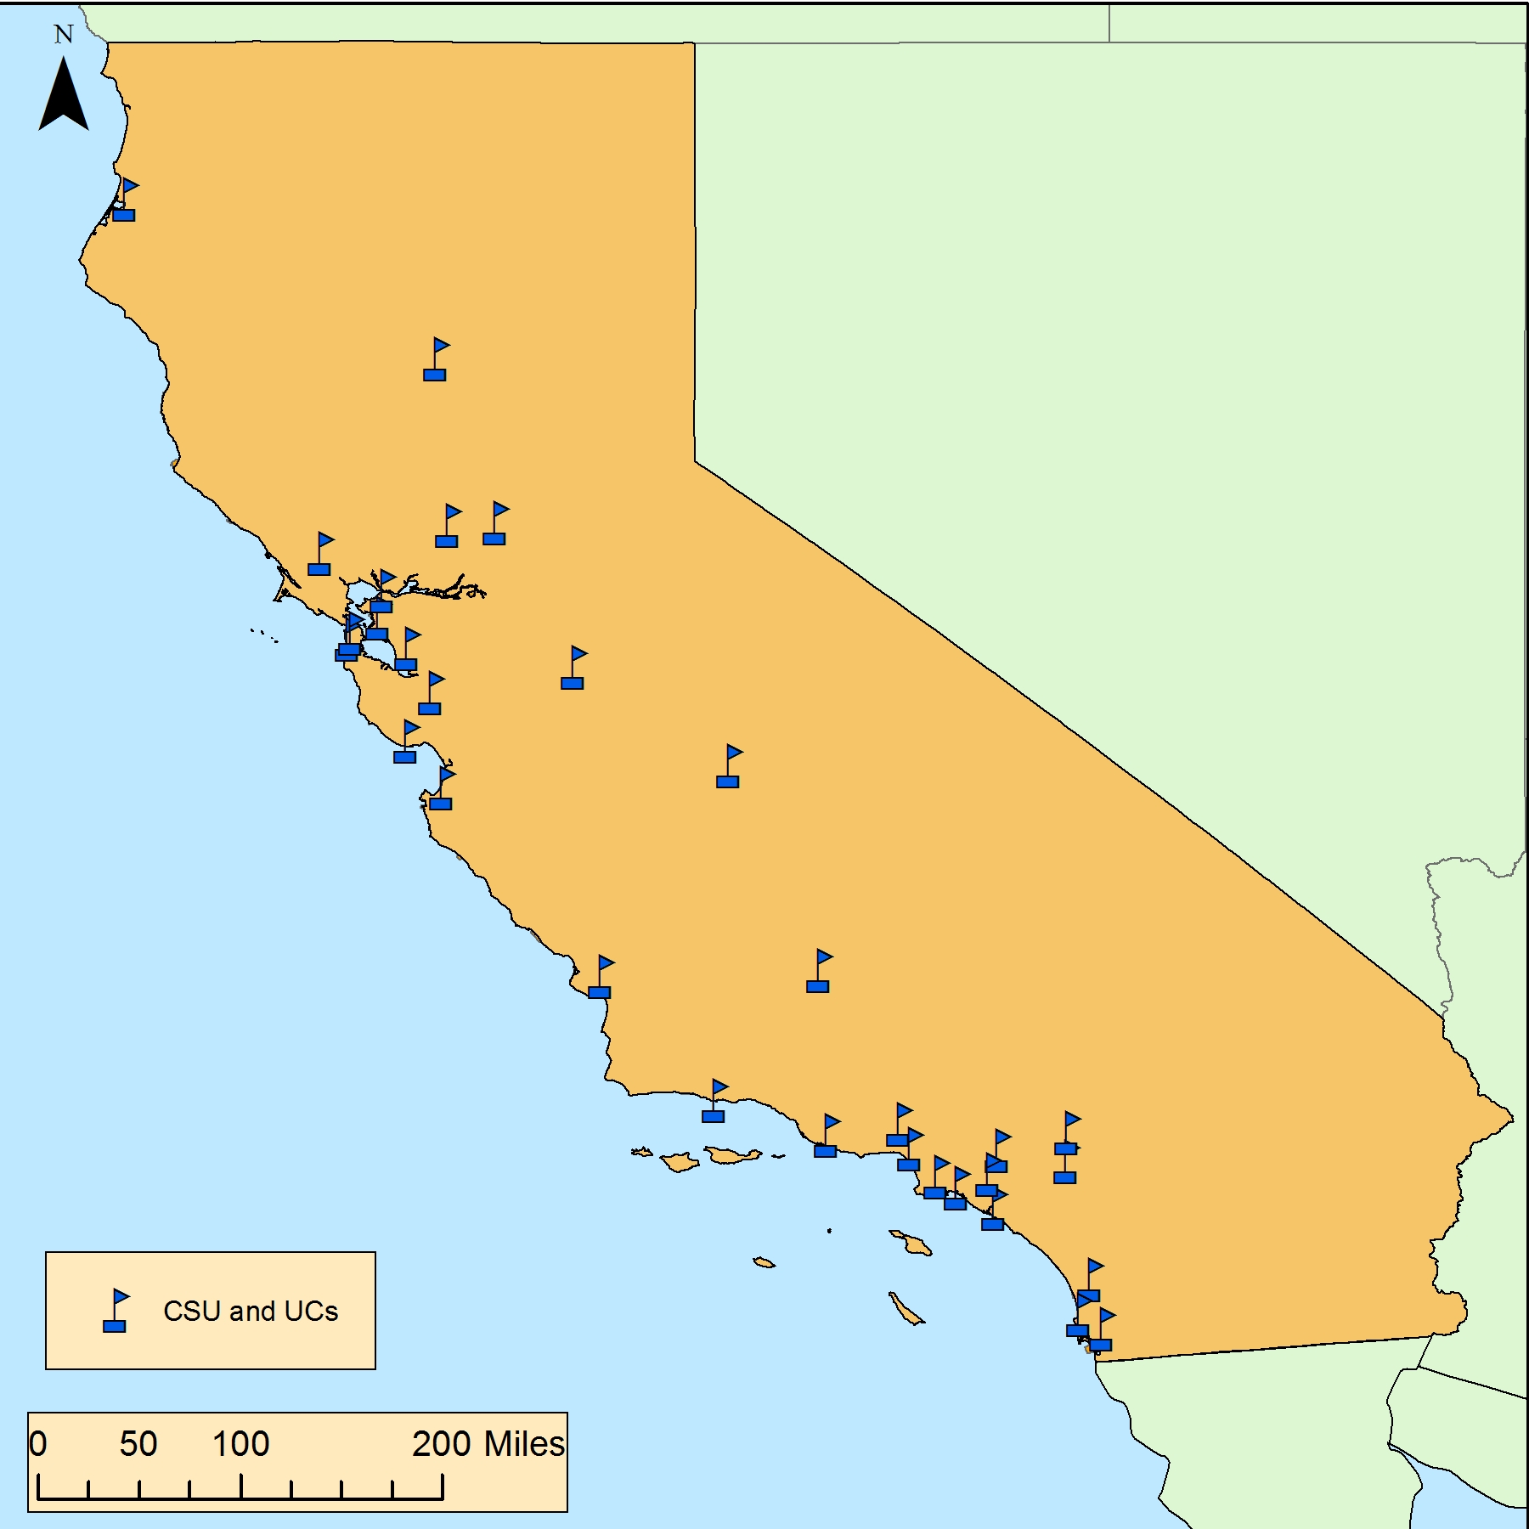
Figure 1. Locator map of California and distribution of CSU and UC schools in California.

Methods
To analyze our data we first acquired the boundaries of the United States then we acquired the data for the boundary of California. After we acquired the data for all federal lands we clipped it to the California boundary. Then, we divided it up using the type of land with the selection tool, and then created a layer from selection tool. Then we acquired the data for California state parks. We then found the coordinates for all CSU and UC schools in California, the compiled coordinates can be seen below in Table 1.
We digitized the schools’ locations by first locating the “create feature class” tool, once you have opened the tool you will want to select the proper location for the new file. After that you will want to create a name for your new feature (such as a school name), then you will want to change its geometry to a “point”, lastly you will want to scroll down “coordinate system” and select the proper coordinate system for your map, (for example we chose the GCS_North_America_1983).
We used the union tool to consolidate all the CSU and UC schools into one shapefile and used the buffer tool to make a 2 mile, 10 mile and 30 mile buffer around each school, and finally clipped the generated buffers using the California boundary. To calculate the area of federal and state that falls within each buffer we consolidated all the public lands using the merge tool and then the dissolve tool. We used the intersect tool to find public lands that intersected with the school buffer.
Before using the geographic calculator, we used the dissolve tool to consolidate the buffer-intersecting public lands into a single layer so as not to have the program double count the area, we then used the geographic calculator to find the area in square miles of public land that fell within any and all buffers. After we downloaded a road shapefile for the cities that we decided to feature in our randomly selected sites (EGIS3.LaCounty.gov, HumboldtGov.org, Ventura.org, Rdw.sandag.org, SonomaCounty.org, MarinMap.org, GIS.Napa.org)

Table 1. List of California State Universities and Universities of California, and their respective central point location coordinates.
School | Location
1. California State University, Bakersfield | 35.3485° N, 119.1025° W
2. California State University Channel Islands | 34.1620° N, 119.0438° W
3. California State University, Chico | 39.7296° N, 121.8475° W
4. California State University, Dominguez Hills | 33.8653° N, 118.2590° W
5. California State University, East Bay | 37.6558° N, 122.0566° W
6. California State University, Fresno | 36.8126° N, 119.7453° W
7. California State University, Fullerton | 33.8829° N, 117.8869° W
8. Humboldt State University | 40.8756° N, 124.0786° W
9. California State University, Long Beach | 33.7838° N, 118.1141° W
10. California State University, Los Angeles | 33.7838° N, 118.1141° W
11. California State University Maritime Academy | 38.0689° N, 122.2308° W
12. California State University, Monterey Bay | 36.6544° N, 121.8018° W
13. California State University, Northridge | 34.2416° N, 118.5287° W
14. California State Polytechnic University, Pomona | 34.0565° N, 117.8215° W
15. California State University, Sacramento | 38.5591° N, 121.4235° W
16. California State University, San Bernardino | 34.1807° N, 117.3241° W
17. San Diego State University | 32.7745° N, 117.0712° W
18. San Francisco State University | 37.7219° N, 122.4782° W
19. San José State University | 37.3352° N, 121.8811° W
20. California Polytechnic State University, San Luis Obispo | 35.3050° N, 120.6625° W
21. California State University San Marcos | 33.1295° N, 117.1591° W
22. Sonoma State University | 38.3394° N, 122.6742° W
23. California State University, Stanislaus | 37.5223° N, 120.8581° W
24. UC San Francisco | 37.7630° N, 122.4574° W
25. UC Berkeley | 37.8719° N, 122.2585° W
26. UCLA | 34.0689° N, 118.4452° W
27. UC Santa Barbara | 34.4140° N, 119.8489° W
28. UC San Diego | 32.8801° N, 117.2340° W
29. UC Davis | 38.5382° N, 121.7617° W
30. UC Irvine | 33.6405° N, 117.8443° W
31. UC Santa Cruz | 36.9914° N, 122.0609° W
32. UC Riverside | 33.9737° N, 117.3281° W
33. UC Merced | 37.3637° N, 120.4311° W

Results
The results of this project were focused on data and map generation. Below in Figure 2, can be seen a full rendering of all federal and state public lands used for this report, in addition to all of the CSU and UC schools with their buffer zones. Table 2, seen below, can be seen that totals of all intersections of applicable public lands and buffer zones of varying distances around university locations. Figures 3-7 below entail various site maps of selected schools from our dataset, these site maps include the buffer zones and street layouts of their respective towns; this was done for clarity purposes, and to show how accessible the shown public lands are relative to the school locations through roads, highways, and freeways.

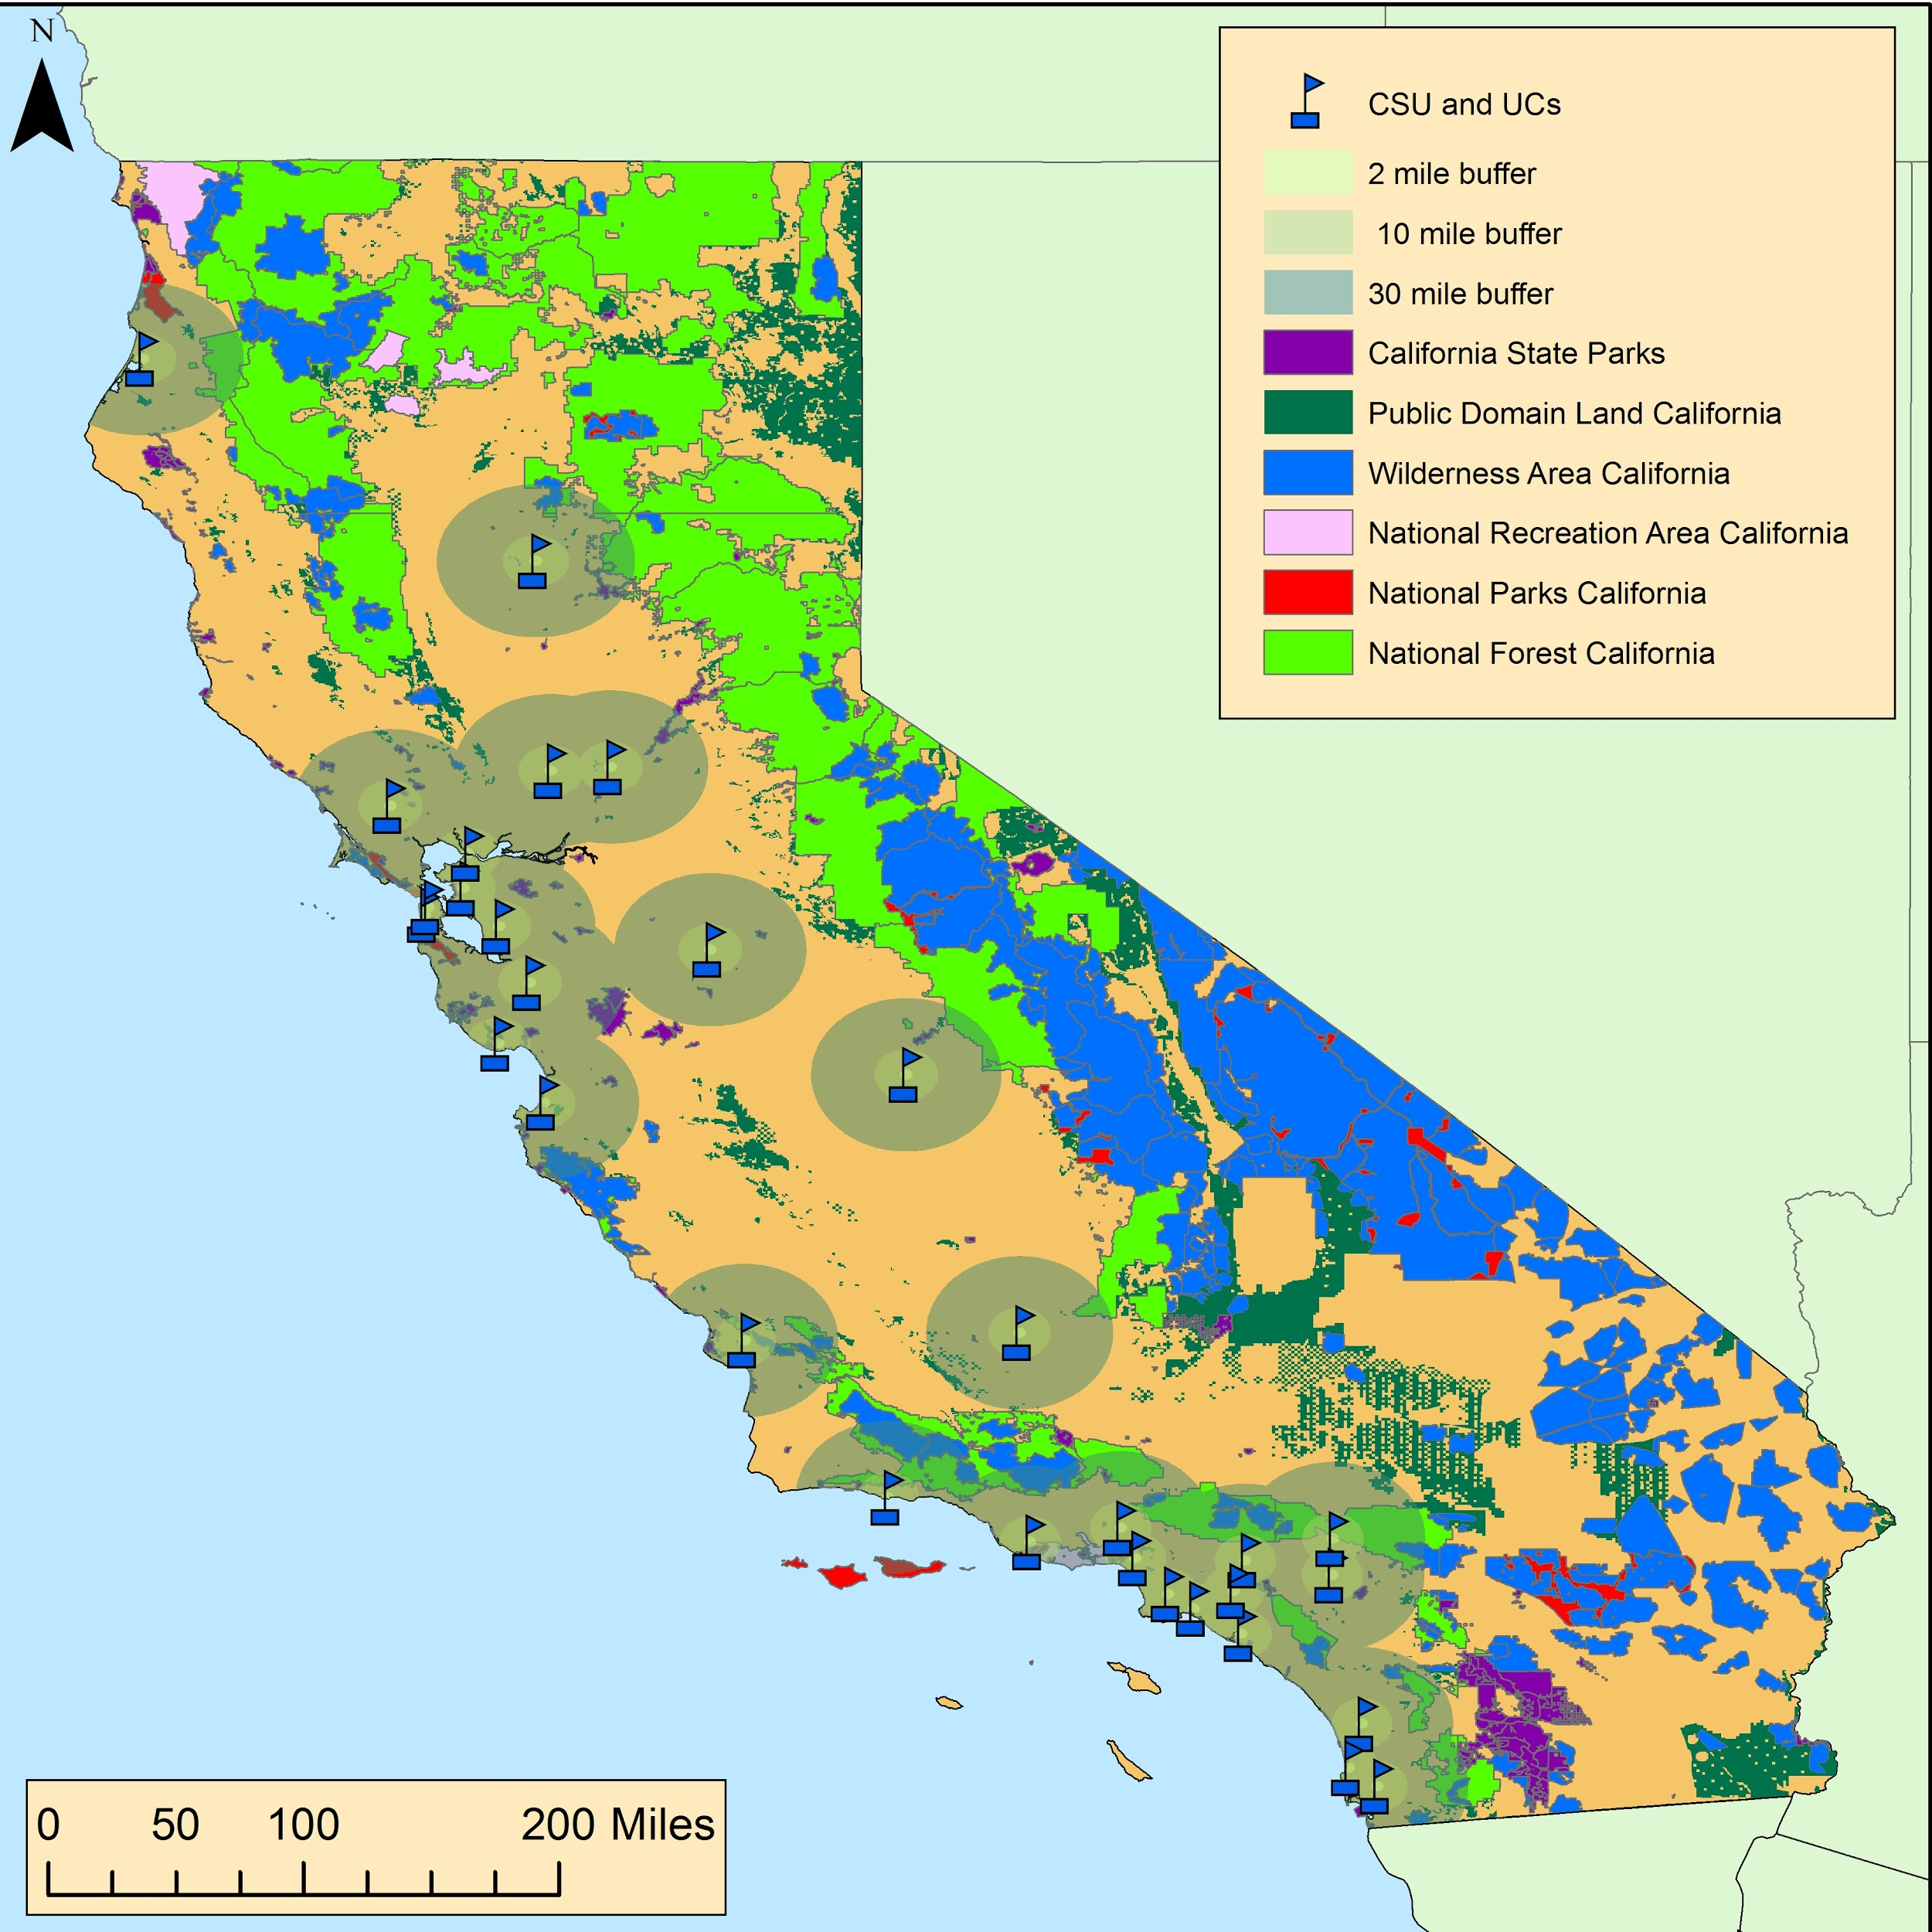
Figure 2. Full rendering of all federal and state public lands used in report, various buffer zones for each university are included.

Table 2. Area of all school buffer overlap with public lands, by distance.
Distance from School | Total Area of Overlap
2 miles | ~12 sq. miles
10 miles | ~504 sq miles
30 miles | ~6,059 sq miles

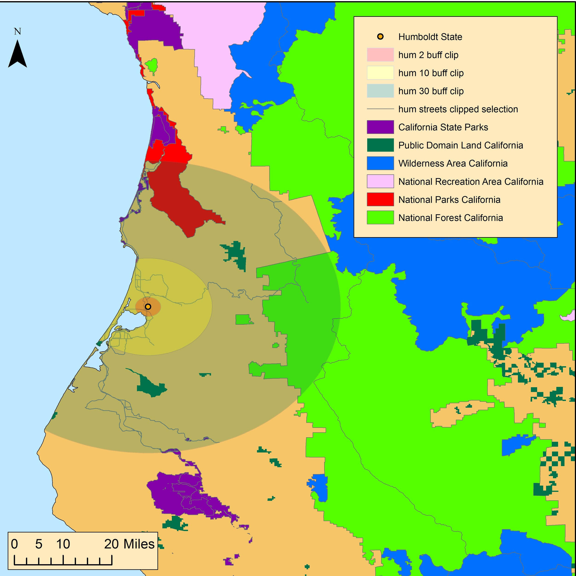
Figure 3. Site map of Humboldt State University, with buffers.

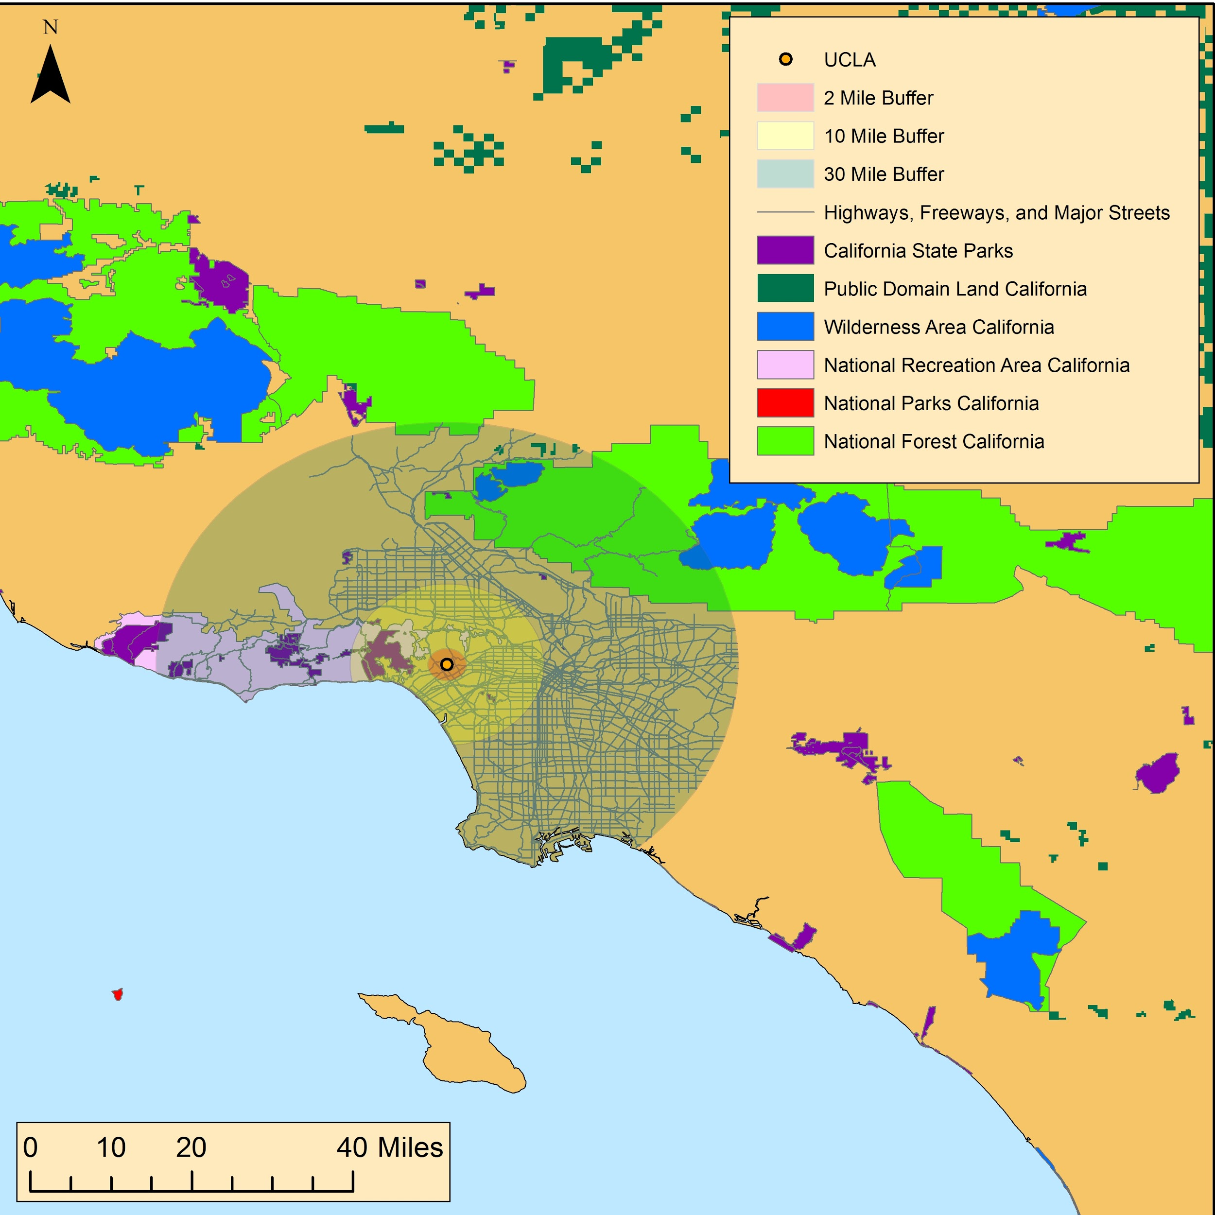
Figure 4. Site map of University of California, Los Angeles (UCLA), with buffers.
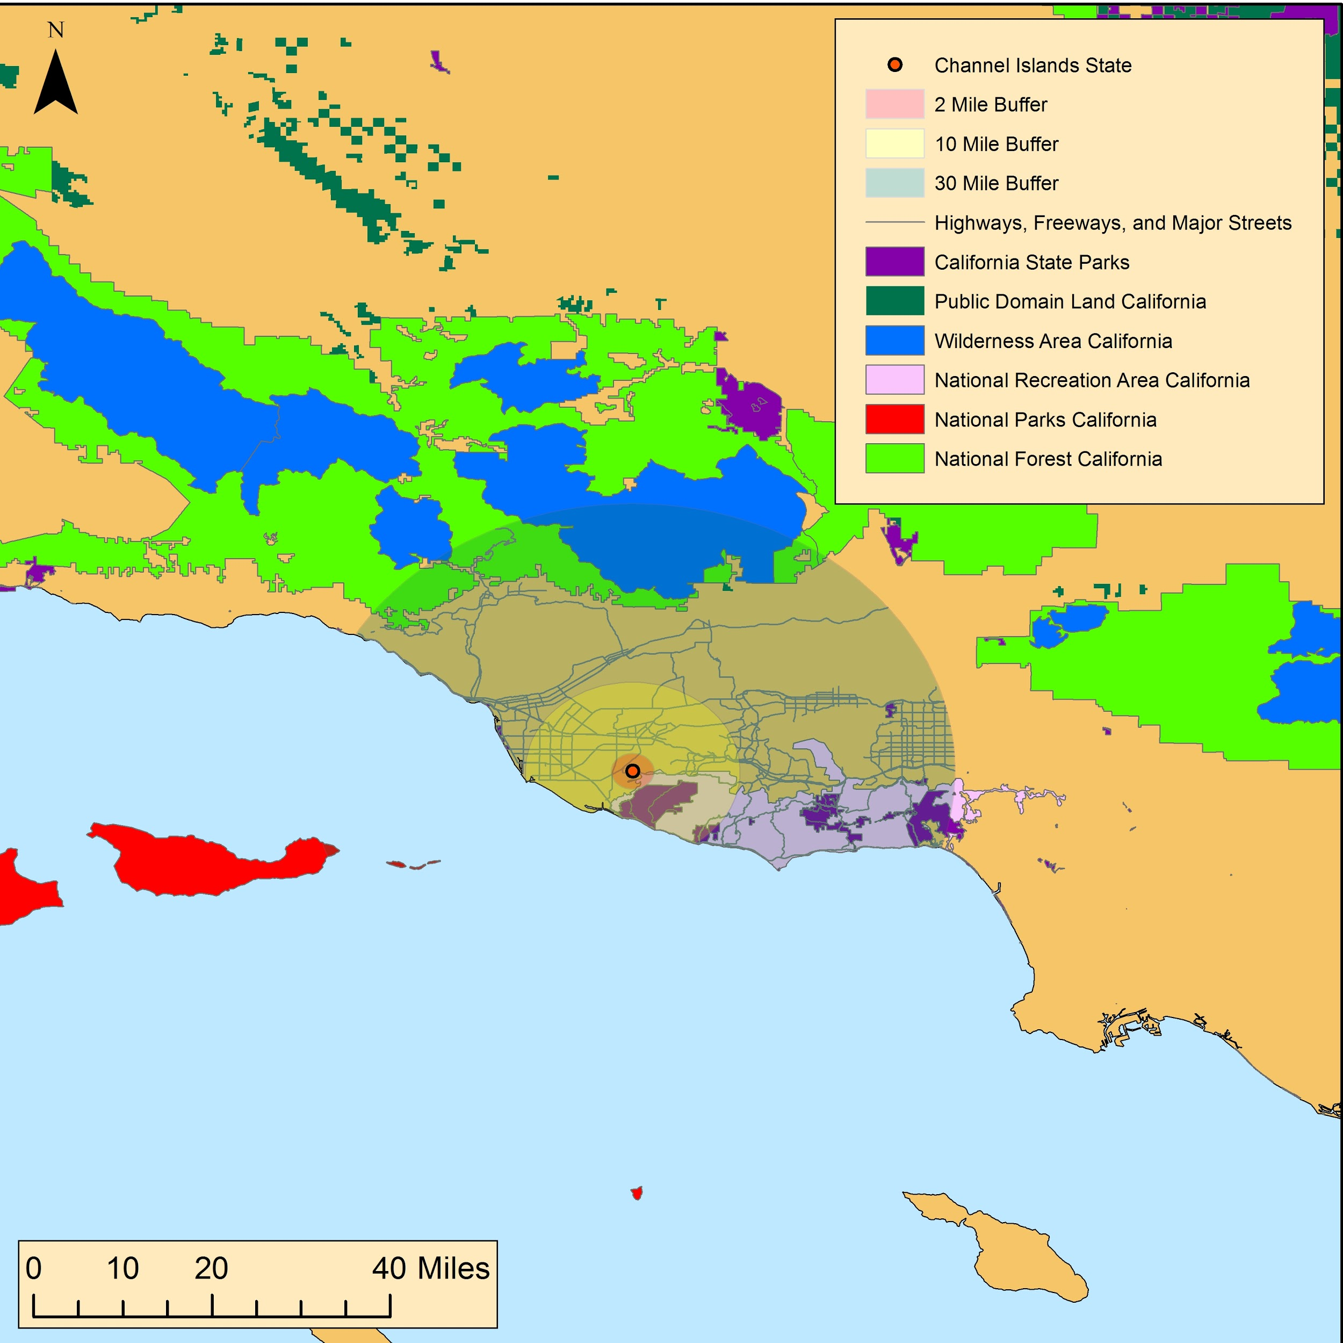
Figure 5. Site map of California State University, Channel Islands, with buffers
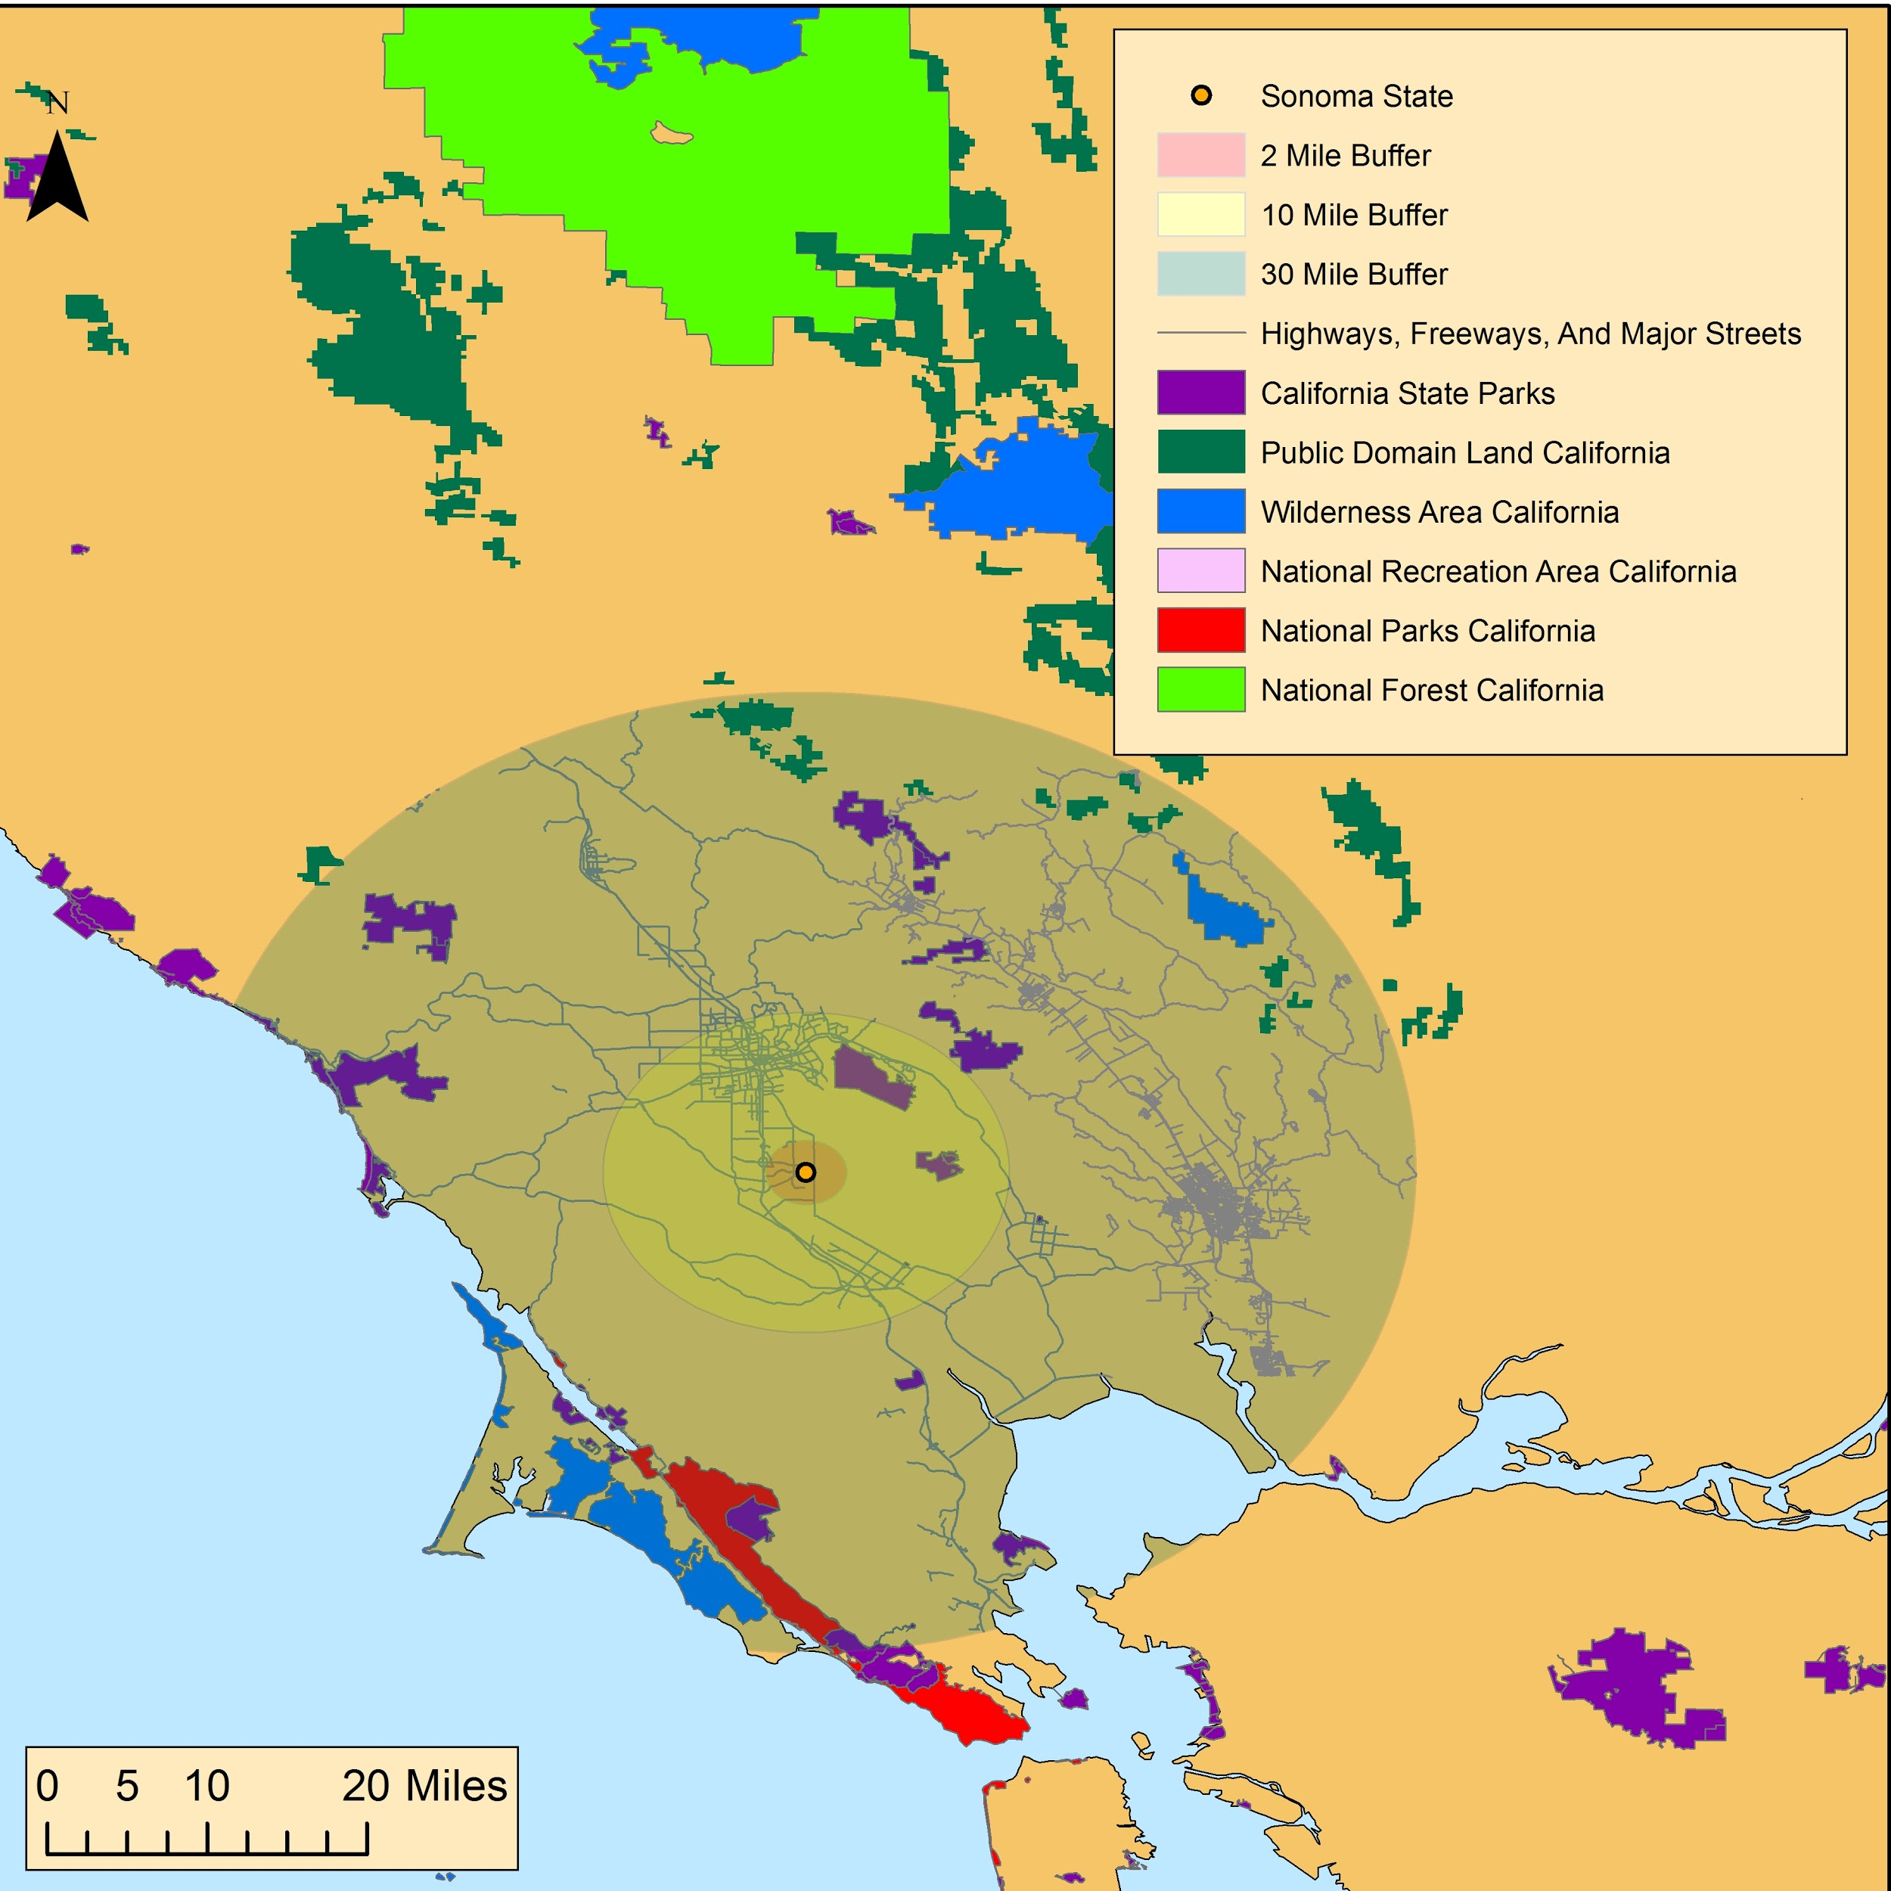
Figure 6. Site map of Sonoma State University, with buffers.
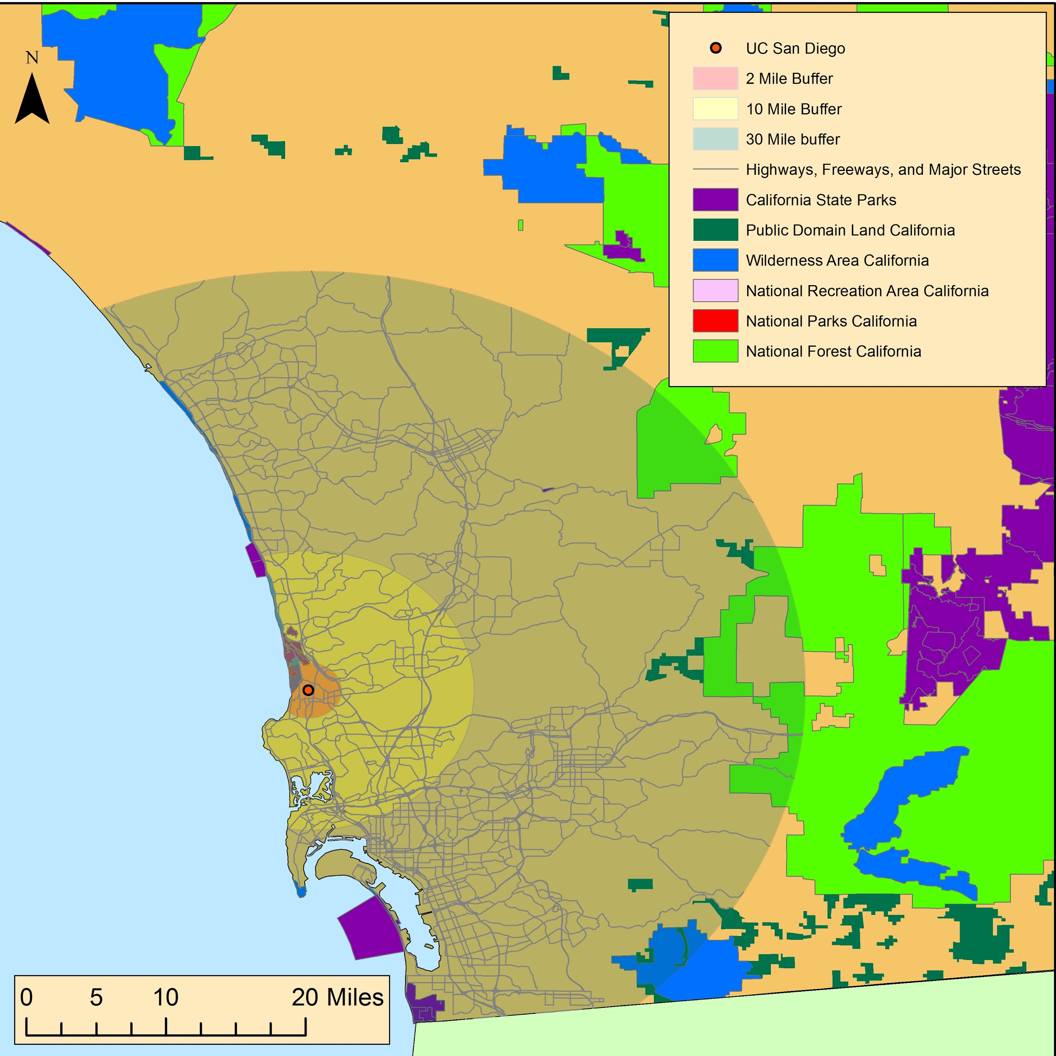
Figure 7. Site map of University of California, San Diego, with buffers.

Conclusion
For this project we sought to find exactly how accessible public lands are to university students and faculty. The idea was a comparative model to the examples set by Humboldt State University’s utilization of the Arcata Community Forest, Redwood National Park, and other public land areas in its natural resources programs. We wanted to see if it were possible for other schools in the Cal State system, and UC schools, to mimic these same programs, if they were in a reasonable distance from public lands, thus project Field Trip. Our secondary objective was to see if students could visit and recreate on public lands within walking or easy driving distances from their respective unitivities. We aimed to find exactly how much federal public lands were made easily available to students. This included calculating the areas of overlap from buffer zones, and finding the area of land that falls within our determined distance for walking, driving, and field trips.
We felt that this report could provide some new information and insight on how other universities could use the resources made available to them.
We feel this report could be improved, in time, when more complex data sets become available. An example of this would be a statewide GIS dataset of California city and county public lands to be included in this kind of analysis. Another complex data set that was not available was a polygon dataset of the university campuses, with their area of cover and the inclusion of the satellite campuses for each; the introduction of this data could make our report more accurate, as we only used the central point locations to calculate our buffer area overlaps.

Bibliography (Cited Works)

- Huhtala, Anni, and Eija Pouta. "Benefit Incidence of Public Recreation Areas—Have the Winners Taken Almost All?." Environmental and Resource Economics, 43.1 (2009): 63-79.
“Of the two supply variables (distance and cost), distance to the nearest SPRA proved to be statistically significant
such that a long distance to the nearest SPRA decreased the probability of participating
in recreation in that area” “state-protected and recreation areas (SPRA)”
2. Weiler, Stephan, John Loomis, and Robert B Richardson. "Recreation as a Spatial Good: Distance Effects on Changes in Recreation Visitation and Benefits." The Review of Regional Studies, 36.3 (2006): 362-380.
“Marginal recreational benefits per trip increased with distance
but at a decreasing rate. However, in-state visitors accrued higher annual benefits because of
greater trip frequency.”
“visitors who
live nearby visit RMNP more frequently (5.9 trips per year) than long-distance visitors
(1.2 trips per year). Therefore, nearby visitors accrue higher annual benefits from recreation
visits because of greater trip frequency (see Figure 6), which is supported by the
revealed preference of residential location.”

Acknowledgements
Special thanks is owed to the data contributors of this projects, whose help and resources were used to generate the maps and other data used for this lab:

Humboldt State University
Parks.ca.gov
NationalMap.gov
HumboldtGov.org
EGIS3.LaCounty.gov
ArcGIS.com
Ventura.org
Rdw.sandag.org
SonomaCounty.org
MarinMap.org
GIS.Napa.org

- State Parks: http://www.parks.ca.gov/?page_id=862
- Federal Lands: http://nationalmap.gov/small_scale/atlasftp.html?openChapters=chpbound%2Cchpbio#chpref
- Humboldt County roads http://humboldtgov.org/276/GIS-Data-Download
- LA county roads
- http://egis3.lacounty.gov/dataportal/2014/06/16/2011-la-county-street-centerline-street-address-file/
- State Boundaries http://nationalmap.gov/small_scale/atlasftp.html?openChapters=chpbound#chpbound
- Mexico State Boundaries: http://www.arcgis.com/home/item.html?id=ac9041c51b5c49c683fbfec61dc03ba8
- Ventura county roads: http://www.ventura.org/gis-mapping/gis-data-downloads-mapping-base
- San Diego roads: http://rdw.sandag.org/Account/gisdtview?dir=Transportation
- Sonoma County roads: https://links.sonoma-county.org/nIhrCoQbqzY/
- Marin County roads: http://www.marinmap.org/dnn/DataServices/GISDataDownload.aspx
- Napa County roads: http://gis.napa.ca.gov/giscatalog/catalog_xml.asp?srch_opt=all&db_name=x&theme=x&sort_order=layer&meta_style=fgdc&submit=Submit

